**Unit Vectors**

- A unit vector is a dimensionless vector having a magnitude of exactly 1. They are used solely as a convenience in describing a direction in space.

Let $\hat{i}$ = unit vector pointing in the +x-axis

$\hat{J}$ = unit vector pointing in the +y-axis

$\hat{k}$ = unit vector pointing in the +z-axis

We will always include a caret or "hat" (^) in the symbol for a unit vector to distinguish it from ordinary vectors whose magnitude may or may not be equal to 1.

The unit vectors $\hat{i}$, $\hat{j}$, and $\hat{k}$ form a set of mutually perpendicular vectors in a right-handed coordinate system, as shown in figure above. The magnitude of each unit vector equals 1; that is, ||=||=||=1.

If vectors **A** & **B** are in terms of its components:

**A** = Ax $\hat{i}$ + Ay $\hat{j}$ + Az $\hat{k}$

**B** = Bx $\hat{i}$ + By $\hat{j}$ + Bz $\hat{k}$

Addition: **A**+**B** = (Ax+Bx) $\hat{i}$ + (Ay+By) $\hat{j}$ + (Az+Bz) $\hat{k}$

Subtraction: **A**-**B** = (Ax-Bx) $\hat{i}$ + (Ay-By) $\hat{j}$ + (Az-Bz) $\hat{k}$

**Product of Vectors:**

Scalar x vector = vector

Ex: Given: vector: A = Ax $\hat{i}$ + Ay $\hat{j}$ + Az $\hat{k}$

Scalar quantity: n

nA = n(Ax $\hat{i}$ + Ay $\hat{j}$ + Az $\hat{k}$)

nA = nAx $\hat{i}$ + nAy $\hat{j}$ + nAz $\hat{k}$

1. Dot product (Scalar product) – results to scalar quantity

**A•B = |A||B|cos(θ)**

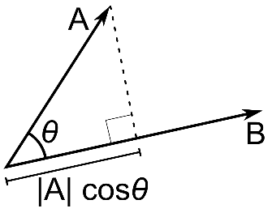

|A| = ; |B| =

If θ=90O, **A**•**B** = 0, since cos(90O) = 0

If θ=0O, **A**•**B** = |A||B|, since cos(0O) = 1

* Dot product of 2 perpendicular vectors is always 0.

The scalar product is commutative; **A•B** = **B•A**

Using the unit vector representation:

**A**•**B** = (Ax $\hat{i}$ + Ay $\hat{j}$ + Az $\hat{k}$)•( Bx $\hat{i}$ + By $\hat{j}$ + Bz $\hat{k}$)

= Ax $\hat{i}$ Bx $\hat{i}$ + Ax $\hat{i}$ By $\hat{j}$ + Ax $\hat{i}$ Bz $\hat{k}$ + Ay $\hat{j}$ Bx $\hat{i}$ + Ay $\hat{j}$ By $\hat{j}$ + Ay $\hat{j}$ Bz $\hat{k}$ + Az $\hat{k}$ Bx $\hat{i}$ + Az $\hat{k}$ By $\hat{j}$ + Az $\hat{k}$ Bz $\hat{k}$

*Dot product of 2 perpendicular unit vectors is 0.

Dot product of 2 parallel unit vectors is 1.

= AxBx + AyBy + AzBz

**A•B = AxBx + AyBy + AzBz**

1. Cross product (Vector product) – vector quantity with a direction perpendicular to the plane of the vector and a

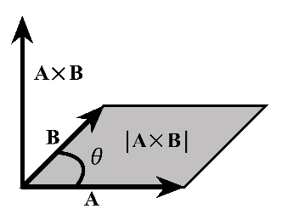 magnitude given by

**AxB = |A||B|sin(θ)**

If **A** & **B** are parallel, θ = 0O then AxB = |A||B|sin(0O) = 0.

There are always two directions perpendicular to a given plane. Use right hand rule.

Using unit vector representation:

**A**x**B** = (Ax $\hat{i}$ + Ay $\hat{J}$ + Az $\hat{k}$) x ( Bx $\hat{i}$ + By $\hat{J}$ + Bz $\hat{k}$)

= Ax $\hat{i}$ Bx $\hat{i}$ + Ax $\hat{i}$ By $\hat{j}$ + Ax $\hat{i}$ Bz $\hat{k}$ + Ay $\hat{j}$ Bx $\hat{i}$ + Ay $\hat{j}$ By $\hat{j}$ + Ay $\hat{j}$ Bz $\hat{k}$ + Az $\hat{k}$ Bx $\hat{i}$ + Az $\hat{k}$ By $\hat{j}$ + Az $\hat{k}$ Bz $\hat{k}$

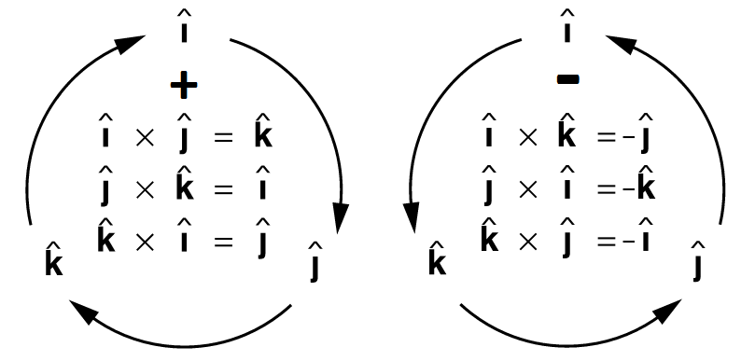

Where:

ixi = 0 ixj = k kxj = -i

jxj = 0 jxi = -k ixk = -j

kxk = 0 jxk = i kxi = j

AxB = (AyBz-AzBy) $\hat{i}$ + (AzBx-AxBz) $\hat{j}$ + (AxBy-AyBx) $\hat{k}$

There is a simpler way to write this. For those of you familiar with matrices, the cross product of two vectors is the determinant of the matrix whose first row is the unit vectors, second row is the first vector, and third row is the second vector. Symbolically…

$\hat{i }$ $\hat{j}$ $\hat{k}$ $\hat{i }$ $\hat{j}$*diagonally downward (+)

A x B = Ax Ay Az Ax Ay diagonally upward (-)

Bx By Bz Bx By

**AxB = (AyBz-AzBy) $\hat{i}$ + (AzBx-AxBz) $\hat{j}$ + (AxBy-AyBx) $\hat{k}$**

**Sample Problems:**

From the reference textbook,

#32 / page 74

#34 / page 74

#36 / page 74

#62 / page 76

Additional Problems:

1. Find the dot product of the two vectors shown in the figure below. The magnitudes of the vectors are *A* = 4 and *B* = 5.
2. Find the angle between the two vectors

**A = 2i + 3j + k** and **B = -4i + 2j –k**

1. Vector **A**has magnitude 6 units and is in the direction of the + x-axis. Vector **B**has magnitude 4 units and lies in the xy-plane, making an angle of 30° with the + x-axis. Find the cross product Ax*B.*

